Nestle Company
University’s Name

Submitted by Names:
Tutor:
Date:

Nestle Company
Nestle Company is among major transnational companies that deal with food and drinks with its headquarters in Vevey, Switzerland. With regards to the metrics and revenues, Nestle is the largest food company in the worldNestle is ranked among the top hundred companies according to the Fortune Global 500, that is ranked number 64 as of 2017There are different lines of products that the Nestle company deals in which includes bottled water, medical food, breakfast cereals, coffee and tea, dairy products, ice cream, snacks and pet foods. There are a number of Nestle products that have annual sales of over CHF 1billion, which is approximately US $1.1 billion.This includes Nescafe, Kikat, Smarties and Nesquik.
Overview
History
Nestle was established in 1905 but it came into existence back in 1866when Anglo-Swiss Milk company of 1866 and Farine Lactee Henri Nestle of 1866 merged. The company grew gradually especially during the 1920s where the company expanded through the introduction of new products with manufacturing chocolate becoming second most important activity. During the First World War and during the Second World War since during the Second World War it is estimated that profits dropped from about $20million to $6million. The company has got a number of track records through major cooperate acquisition including Crosse & Blackwell in 1950, Findus in 1963. Nestle is among the Fortune 500 companies and this proves its greatness.
Mission
The cooperate mission of the Nestle company is based on the belief that research can make better food which will contribute to the wellbeing of consumers. As consumers makes choices about their products, Nestle company, provides a wide range of selections for all its products so that consumers can choose according to their preference and choices.

Vision
Vision of the company is to meet the needs of the consumers through aggressive marketing and selling foods of consistently higher quality. Good food equates to good health and therefore the objective of the company is to make good food available to the consumers. This in turn ensures that the consumers obtain an optimal health benefits.
Cooperate Strategy
Global Brand Strategy
As organizations are getting more diversified and in the case of Nestle which is a global company the focus is not only about the business-level but cooperate level decisions with the primary purpose of uniting the different business of the company within a single global company (Johnson, Scholes, Whittington, 2009). Nestle has a global brand strategy with the main aim of ensuring that the products all over the world are unified, with regards to their quality. Therefore, all over the world the company has to obtain a reputation of “Good Food Company. Nestle company, being a global company has incorporated diversification, due to the different lines of the company’s product. The main reason as to why a company such as Nestle undertakes this cooperate strategy is because, the company controls the values added activities in more than a single country (Dunning, Lundan, 2008).

Trend of How Nestle Has Achieved this Strategy
 | 2001 | 2012
Total Group Sales | 83642 CHF Million | 92186 CHF Million
Net Profit | 9487 CHF Million | 10611 CHF Million
Renovated products for nutrition or health considerations | 5066 CHF Million | 6692 CHF Million
Products with increase in nutritious ingredients or essential nutrients | 3851 CHF Million | 4691 CHF Million
Products with reduction of sodium, sugars, trans-fatty acids, total fat or artificial colourings | 1215 CHF Million | 3317 CHF Million
Products containing Branded Active Benefits  Products featuring Nestlé Nutritional Compass labeling | 5563 CHF Million | 6455 CHF Million
Products in EU with Guideline Daily Amounts (GDA) labelling | 98.0 CHF Million | 96.8 CHF Million
Popularly Positioned Product (PPP) SKUs | 5556 CHF Million | 6367 CHF Million
Source: http://www.nestle.com/asset-library /documents/ library/ documents/ corporate_social_responsibility/nestle-csv-full-report-2012-en.pdf

The above information entails the difference in sales of the various Nestle Products from 2001 to 2012. The increase in sales of the various products demonstrates how the company is implementing its cooperate strategy.
Nestle is a rapid growing company and thus strategies include market segmentation strategies, there are manufacturing strategies, sales strategies and warehousing strategies as part of its operation management.
In its manufacturing strategy, the produces its products based on the demands. Demand of particular product is mainly forecasted depending on the sales and marketing results that the company gets. There is an integration of the ERP system which facilitates the company forecast of the , which is primarily a form of the SAP system. For instance as it is with the branches in Pakistan for instance, the company has hot climates in the moths of June, July and August, the demand of products such as juice tends to rise and thus it becomes a seasonal trend. THE ERP system in the company manufacturing sector, allows for the company to plan for a forty-five days cycle in the manufacturing sector. Additionally orders from local suppliers have to be manually dispatched, since suppliers especially the local ones do not have SAP.
In the warehousing strategy, the company has an ERP system put in place that enhances easy operations within the organization. Geographical information system is a very useful technique that has been incorporated in the warehousing strategy. The development of this particular system enhances multi facility warehousing and the production system distributed within a very wide area. Geographical information system has unique capacities that enhances a rapid decision making. In this modern environment, the data in the warehousing even with the absence of the ERP system should aim at achieving specific sets of the business environment and meet the predefined set of the business strategy (David et al, 2000).
All through the sales process, sales person carry out sales concession strategies that build the professed value of their solutions and will end up encouraging their customers to pay higher prices because of the perceived quality (Ron D’Andrea, 2005).
The primary purpose of the operation strategy of any given company is to ensure that the company successfully links the internal and external operations. Nestle company undertakes a market segmentation as the operation strategy. In this way the company involves in looking for common characteristics within a particular market and thus design products that can suit the needs of the particular market. Often this operation strategy aims at targeting the demographic profiles that exists within a given market. They believe that for a business to be health and competitive they need to invest continuously on their brands through making increment on the quality of adverts they make especially on media. Thirdly, the firm makes sure that they are efficient in that any step that is taken towards constructing momentum for growth, there is the need of investing more marketing and ensuring flexibility of finances. Last but not least, the firm has made sure that they have simplified their operations. This has been done through looking vividly at those areas that they can be more efficient, smart and faster so as to cope with the rapid changing of other industries that produce almost similar products that can influence the marketing.
Supplier Network
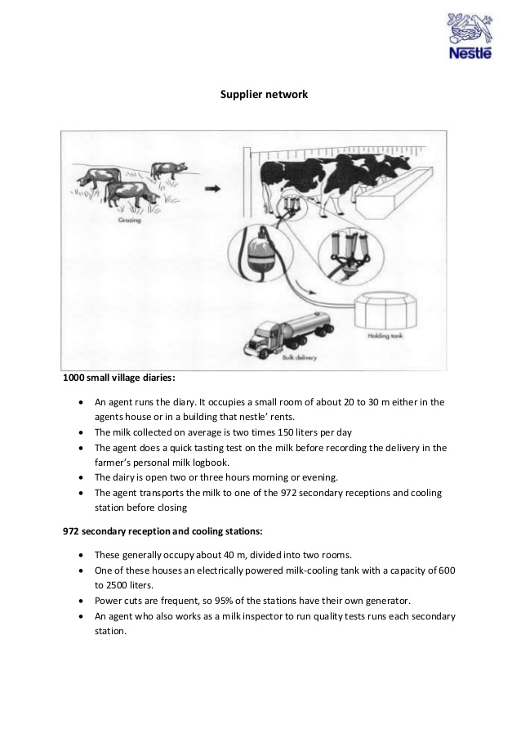
A company that operates in any environment is prone to challenges ranging from the internal to external challenges. For instance, integrity is one of the challenges whereby in the current world each one is struggling hard to succeed in the business and earn more income, compete favorably and maintain their course. As a result there might be cutting of corners, using unsubstantiated information so as to move ahead. To curb these incidents, the company needs to maintain the trust that exists between them and their customers. Also another challenge is financial management and this is a serious one since failure to manage funds this may affect the production and so the managers and all the stakeholders ensure that the funds are used as budgeted so as to prevent overspending hence resulting to high losses.
One of the biggest problems that brought Nestle to the spotlight is the use of Child Labor by its suppliers. Though this might indirectly involve a company since upon looking at the company record one might find that they are clean. This problem was brought to light in 2005 when the International Labor Rights Fund filed an affidavit against Nestle (among) other companies due to its link on the use of child labor. The International Labor Rights on behalf of three Malian Children MHAI ANDRE (2017) did this. This problem has adverse effects especially on the image of any given company although largely it is the suppliers who are involved. According to the Fair Labor Association Nestle was fully aware of where the suppliers got the Cocoa from and the conditions involved in getting the product. This, therefore, meant that Nestle was to be held very responsible for the mess.
government policies also pose a challenge in operating the firm whereby amendment of new policies may be continuous and too rigid for the execution of company’s activities and for the company to succeed they need to be flexible so as to cope with these changes. Taxation rates may be too high in the state because of the notion that the firm is big and can afford to pay. The firm needs to make sure that they maximize profits so as to attain the target. Also competition is another challenge that the firm can face especially from other companies who sell beverages. To solve this issue the firm should put more emphasis in producing quality products and try as much as possible to retain customer relation to gain their loyalty.
It is usually in the interest of any ethical company to avoid being linked with labor issues especially the involvement of children in its production process. They can be able to ensure that original producers are able to follow a globally accepted code of conduct by establishing an effective supply chain management. This is so because the firm has a supply chain management that is responsible for overseeing all the process that is involved in securing raw materials all the way down to making a finished product that is ready to be consumed. When for instance for issues that involve child labor which is unacceptable the companies should be able to establish consultations with the suppliers which aims at reducing the use of child labor during production for this to be effective the company can adopt effective approaches that can ensure that the producers adhere to the accepted code of conduct. Embeddedness approach could help firms to deal with labor issues such as child labor as here the firm calls for the adherence of its code of conduct, which is deemed ethical by the outside suppliers.

PEST Analysis
PEST analysis, some of the political factors affecting the enterprise macro-economically are government instability due to raptures and election violence where different races and tribes fight against each other. This is basically true for overseas branches of the company. This brings about fears in dynamic investments where you will need to interact with various tribes. This is similar to insecurity and government intervene with immediate notice since it is the right of the enterprise to optimize profits.
Economically, some of the identified factors affecting the enterprise macro-economically is the inflation rate as well as the increased interest rates in the nation. this is due to government policies through economic control measures. Rise in interest rates increases cost of borrowing thus low rate of investment. This will thus attract slow economic growth and development since the investors will diverge their elsewhere, consumer rate goes down and government tax shoots down.
As well, rise in value added tax might make the consumers shy off from current consumption rate thus affecting the M and M consumer goods distribution. This is part of an economic factor. To extend the analysis, the enterprise shall also be affected basically by tribalism and racism. With tribalism, one cannot expand or open a branch within a society with a different tribe since they may end up disrupting the business up or not purchasing from the enterprise.
With the technological factor, improvement in technology, say such as use of ATM, mobile banking, payment through Visa cards and Till numbers will negatively affect the illiterate personnel in the enterprise since it will be in need of skilled personnel to cope with the modern system of technology thus thriving in the economy.
Recommendations for Resolving Some of the Problems
Continuous monitoring and evaluation at the grassroots level are also very important in dealing with this issue. This involves carrying out private surveys that will involve engaging with the original producers, those involved in surveys and using observation methods the company will be able to realize if there are any labor issues involved. Financial assistance can be directed to the families that their children work for the suppliers of these companies so that to fill the gap these children leave that when they stop working. This is so because it is obvious that poverty levels are usually the reasons why the children are offering their labor in working cites. It can involve working with influential NGOs and ensure that the kids are able to attend school. This cannot involve the mere collaboration but in areas where the company believes that child labor might be used then it is important for the company to donate to the organizations involved in ending child labor.
The use of technology can also be used in mitigating the labor issues that Nestle faced. The use of technology is more cost-effective as compared to the continuous monitoring and evaluation, which involves the use of many resources. Technology might be used to enhance instant reporting when the company detects the use of child labor in any process. International Labor Organization, for instance, has developed an application called LISA, which can take pictures of any violation of labor laws and especially child labor. The images taken are then sending to the Supply Management Team for effective action to be taken thereafter. This will enable the company to hold the involved supplier responsible.

The company should also establish an online portal that will help the registration, rescuing and rehabilitation of child workers. In a way, the company will be able to bring together the responsible officials, charitable organizations, and law enforcers to share information and establish a strong coordination on child labor cases. This online portal will enhance the creation of awareness also with the main aim of ending child labor. The portal will effectively work with the LISA app since the photos can be posted for individuals to see it. The portal might include a child tracking system; provide a forum for complaints and operating procedures. One of these kids had been established in India and it could effectively work in Nestle to fight labor issues.
The use of Chain point technology as in the case of Good weaves can also be very effective. This involves developing an information system in form of a database for all the activities involved in supply management. In this information system, there will be all the activities involved in producing all the way to manufacturing, information capturing through interviews, and making a follow-up to see if the supply complies with the accepted code of conduct.
Primary Activities
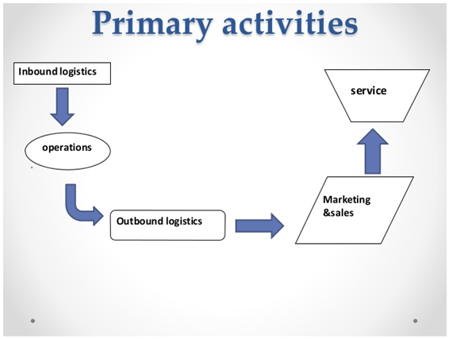
Lean Management
Lean management is a technique to operating a business that supports the idea of constant upgrading. It is a constant endeavor to improve services, products, or processes, which require “incremental” enhancement throughout time in order to enhance efficiency and quality.
Lean management integrates the use of various methods to eliminate factors results into inefficiency with regards to time and financial resources. This is accomplished by taking a critical analysis of the process of the business and thereafter then revising it or cutting out any steps that do not create value for customers.
In most cases lean management integrates the following principles in its operations:
- Determining the value depending which initially arises from the customer point of view.
- Critically identifying each step in the business environment. This enables the identification of the different steps that requires rectification or the ones that can be totally be eliminated.
- Making the value-creating steps occur in firm chain.
- Replicate this first three steps as listed above on a constant basis until all the wastes are totally contained. These lean principles ensure that the processes involved with bringing a product to market remain cost effective from beginning to end.
Lean production or lean manufacturing is a organized method for the exclusion of misuse in a manufacturing process. This might constitute wastes produced during irregularities in work loads, overburden and any work that does not add value. According to customer point of view, a service or product service is basically what the client is willing to pay for the service.
Lean management refers to continuous efforts towards improving services, products or procedures that are aimed to advance over time to raise the efficiency and quality. Lean management has some benefits which are: Main focus of lean is to eliminate avoidable activities, expenditure, workforce, stocks, and space of work to reduce the cost but increase the efficiency. Also, the amount of waste (example, inventory, overproduction, rework, transportation, motion and waiting) is reduced hence improving the quality of products and services which is of great benefit to the customer. Lean also leads to employee satisfaction and retention since they are being involved in any improvements that the company makes. Moreover, the business will be highly sustainable especially when lean is incorporated into it.
Quality management is the process of managing all the activities and functions activities aimed at defining procedures for quality and its quality through means such as planning and reassurance of quality. There is offline quality management which includes the following: Tracking the complaints from the customer’s intake through surveys and efficient checks to reduce the risk of product and regulatory issues. Also, ensure continuous improvement by the use of devices that support offline access. Another one is Identifying center for recording occurrences to allow investigations and lastly is enabling active communication with customers. Online quality management includes; Digitization processes and forms so to modernize, automates, and standardizes the implementation of counteractive and defensive activities.
Quality, for instance, can have a positive impact on lean management because you find that lean mainly focuses on the quality improvement to reduce the cost of expenditure used and maximize the profits. Also on the negative side, quality can negatively impact lean in the sense that when trying to improve the quality there will be cases of sudden confusion when making reversals, or at least significantly reduce initially planned target effects.
Illustration of the Process at Nestle Company
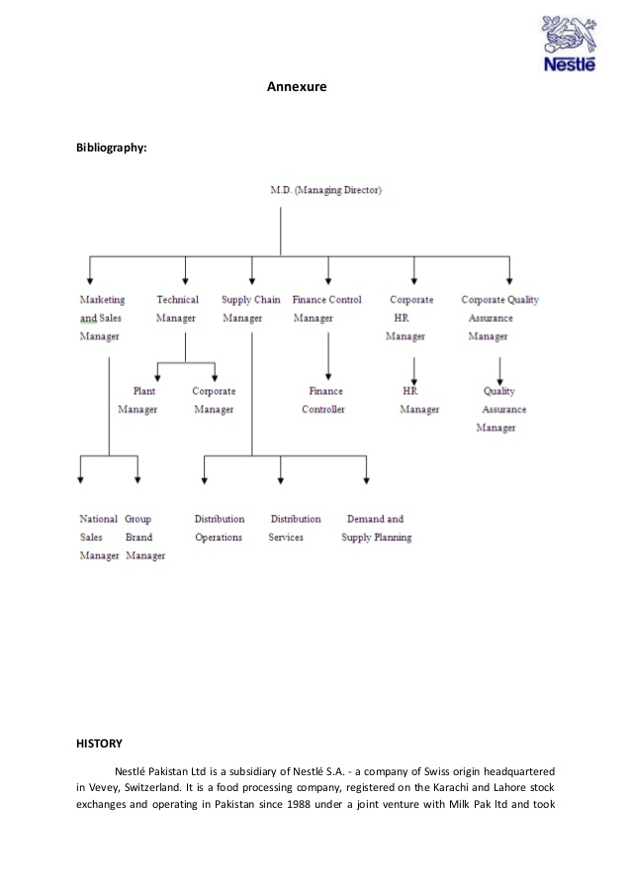
How Artificial Intelligence can enhance the overall business operations of the organization.
The use of artificial intelligence machines like robots (Russell & Norvig 2003, pg,55).)for example, can make work more comfortable and can do a lot of task in a concise time. The cost of production also may be cut down since there will be few numbers of employees and hence the profit margin may increase. The workforce may be tiresome especially in a business that produces heavy products, but the machines can quickly provide them without putting much effort. Moreover, the decisions that are needed to be made becomes faster and accurate since the machine is automatic, and it has been programmed in such a way that it can reduce the time that could have been used in deciding what to fix first even if it is a big task (Chang,2017, pg 288). Also, it can be easy to access big data within a short time compared to human beings. This can allow even to predict the prospects and endorse actual actions your manufacturing company can take today to take advantage of on those opportunities.
Contrarily, the use of artificial intelligence has its negatives for example if these machines are misused it will lead to mass destruction which probably causes a significant loss (Ford, 2015, pg 21). Also, the cost of purchasing this machines is very enormous than even hiring human beings, and even maintenance is too high which may take the company more extended period to recover if some get a break down inside those machines.

Assignment Task 2
Project Plan
Project Objectives
The primary objective of the AI software is to make a secure manufacturing system. This will make it easier to monitor the manufacturing process and thus reducing labor costs. Additionally the AI, the software will provide an efficient method for managing records. Therefore, to be precise, the primary objective is to make the operations of the company profitable.
Organizational Objectives
To reduce the operational costs of the company.
Project Scope
The project scope of the AI software entails the goals of the project, features, the functions, tasks and ultimately the cost of the project. The goal of the project is mainly associated with the overall goal of the organization at large which is to enhance the company’s efficiency, especially with regards to time. This correlates with the organizational goals whereby the main aim is to promote customer satisfaction. The AI software will have the functions of driving different machines that are used in the manufacturing sector. Installation of the software costly to the company and it is estimated it will cost a tune of $1million. This covers all the costs that will be associated with the installation, that is even paying the human resources that will be outsourced to make the project a success.
Project Assumptions
Since its part of the change, that aims at transforming the operations of the company there are many project assumptions. First assumptions are that the project will be concluded strictly within the specified time frame. Therefore if the company does not complete the project within the specified time, then other plans might be endangered, and thus there is a need to allow adjustment. The second assumption is that the resources required for the implementation of the project will be acquired within the specified period to avoid delays. The third assumption for the project is that personnel who will be outsourced will deliver quality work according to the standards of the company. All the relevant stakeholders who are responsible for driving the success of the company and thus they will all support the idea of the project. Finally, there will be additional costs that will be incurred by the company if in any case there is a strong will to achieve an absolute success.
Project Roles and Responsibilities
The executive sponsor has the ultimate authority of the project. The different roles that the executive sponsor is tasked to include the approving changes to scope, provide additional funds for scope changes and approves the deliverables of the project.
The executive committee has a wide range of functions which includes, the ability to allocate resources to support the implementation of a project, gives priorities to the different projects, provides information and expert advice about the project. Additionally, the executive committee should be able to advise on strategic partnership.
The steering committee will be able to provide leadership, resolves the issues that are raised by the project manager and forwards policy issues to the concerned decision making bodies.
The project sponsor will be responsible for making the materials for the project available, approve work products and ensure daily participation.
The project manager has the responsibility of overseeing the successful completion of the project. The project manager is also tasked with the responsibility of managing and reviewing the work plans of the project to give priorities to the project. He is also responsible for monitoring the compliance of the contractors.
Project team leader will be responsible for participating in full activities of the project, contribute and promoting the overall objectives of the project and coordinate both the documentation, testing, and the training efforts.
Project team members have the total responsibility to participate in the project activities.
Time line with Gantt charts
Activity | Timeline
 | May-August |  | August |  | September to March of 2019 | May of 2019
Project Proposal
Committee approval
Tender Notice
Approval of tender
Assembling the specific resources
Implementation
Assessing the Outcomes of the project

Risk Management
The project assumptions form the basis of risk management. Therefore since there are changes, it is crucial to involve the team members in anticipating the change. There will be rigorous communications and detailed information concerning the project and how the project might change the operations of individuals. This will ensure that the project members can implement the project with minimal resistance. Furthermore, there will be a need to provide room for adjustment because of the future changes that might take place, which might not be anticipated. This calls for coming up with proactive adjustment measures that can contain any deviations in future.
Stakeholder Management
All the stakeholders are expected to attend every meeting of the project to have firsthand information on prior the implementation of the project. This will ensure that during the implementation phase, there will be maximum cooperation as all the stakeholders will be aware of what is anticipated of him/her. However, if stakeholders miss meetings concerning the project, follow-ups will be made to ensure that they are debriefed.
Project Funding
Project funding needs will be facilitated by the company with the partnership of some of the technical agencies of the government. Approval of the funding proposal for the particular project that the company is undertaking will mean that the company will be able only to facilitate part of the project funding.

References
Hsihui Chang; Yi-Ching Kao; Mashruwala, Raj; Sorensen, Susan M. (10 April 2017). "Technical Inefficiency, Allocative Inefficiency, and Audit Pricing." Journal of Accounting, Auditing & Finance: 0148558X1769676. doi:10.1177/0148558X17696760.
Johnson, G., Scholes, K., Whittington, R. (2009). Fundamentals of strategy. Harlow:FT Prentice Hall.
Dunning, J.H., Lundan, S.M. (2008). Multinational enterprises and the global economy. Edward Elgar Publishing Limited.
David A. Johnston, G. Don Taylor and Ganesh Viswes wara murthy. Highly constrained multi-facility warehouse Management system using a GISplatform, 1999, Integrated Manufacturing System, Vol.10, No. 4, Page 221-232.

Ron D’Andrea. Executing profitable sales negotiations: selling value, notprice, 2005, Industrial and Commercial Training, Vol.37, No.1, Page 18-24

